**Assignment -2**

Data Visualization and Pre-processing in ipynb

|  |  |
| --- | --- |
| Student Name | Naveen Kumar A |
| Team ID | PNT2022TMID20551 |
| Maximum Marks | 2 Marks |

1.Download the dataset

import numpy as np import pandas as pd import seaborn as sns

import matplotlib.pyplot as plt 2.Load the dataset

df=pd.read_csv('/content/Churn_Modelling.csv') df.head()

RowNumber CustomerId Surname CreditScore Geography Gender Age \

1. 1 15634602 Hargrave 619 France Female 42
2. 2 15647311 Hill 608 Spain Female 41
3. 3 15619304 Onio 502 France Female 42
4. 4 15701354 Boni 699 France Female 39
5. 5 15737888 Mitchell 850 Spain Female 43

Tenure Balance NumOfProducts HasCrCard IsActiveMember \ 0 2 0.00 1 1 1

1 1 83807.86 1 0 1

2 8 159660.80 3 1 0

3 1 0.00 2 0 0

4 2 125510.82 1 1 1

EstimatedSalary Exited 0 101348.88 1

1 112542.58 0

2 113931.57 1

3 93826.63 0

4 79084.10 0

df.info()

<class 'pandas.core.frame.DataFrame'> RangeIndex: 10000 entries, 0 to 9999 Data columns (total 14 columns):

# Column Non-Null Count Dtype

|  |  |  |  |  |  |  |
| --- | --- | --- | --- | --- | --- | --- |
| 0 |  | RowNumber | 10000 | non-null |  | int64 |
| 1 |  | CustomerId | 10000 | non-null |  | int64 |
| 2 |  | Surname | 10000 | non-null |  | object |
| 3 |  | CreditScore | 10000 | non-null |  | int64 |

* 1. Geography 10000 non-null object
  2. Gender 10000 non-null object
  3. Age 10000 non-null int64
  4. Tenure 10000 non-null int64
  5. Balance 10000 non-null float64
  6. NumOfProducts 10000 non-null int64
  7. HasCrCard 10000 non-null int64
  8. IsActiveMember 10000 non-null int64
  9. EstimatedSalary 10000 non-null float64
  10. Exited 10000 non-null int64 dtypes: float64(2), int64(9), object(3) memory usage: 1.1+ MB

1. Perform Below Visualisations Univariate Analysis df['Geography'].value_counts()

France 5014

Germany 2509

Spain 2477

Name: Geography, dtype: int64

*# comparison of geography*

plt.hist(x = df.Geography, bins = 6, color = 'lightblue') plt.title('comparison of Geography') plt.xlabel('Geography')

plt.ylabel('population') plt.show()

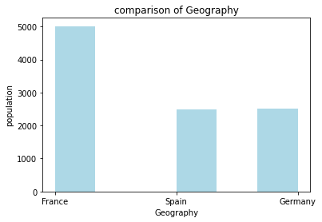

df['IsActiveMember'].value_counts()

1 5151

0 4849

Name: IsActiveMember, dtype: int64

*# How many active member does the bank have ?*

plt.hist(x = df.IsActiveMember, bins = 5, color = 'pink') plt.title('Active Members')

plt.xlabel('Customers') plt.ylabel('population') plt.show()

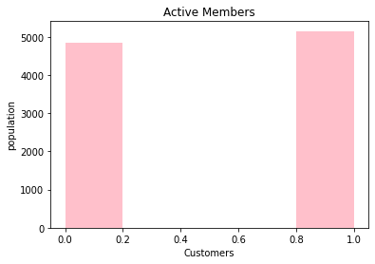

df['Gender'].value_counts() Male 5457

Female 4543

Name: Gender, dtype: int64

*# Plotting the features of the dataset to see the correlation between them* plt.hist(x = df.Gender, bins = 4, color = 'lightgreen') plt.title('comparison of male and female')

plt.xlabel('Gender') plt.ylabel('population') plt.show()

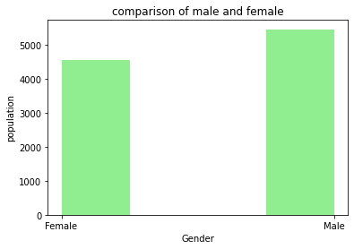

df['Age'].value_counts()

|  |  |
| --- | --- |
| 37 | 478 |
| 38 | 477 |
| 35 | 474 |
| 36 | 456 |
| 34 | 447 |
| ... | |
| 92 | 2 |
| 82 | 1 |
| 88 | 1 |
| 85 | 1 |
| 83 | 1 |
| Name: | Age, Length: 70, dtype: int64 |

*# comparison of age in the dataset*

plt.hist(x = df.Age, bins = 10, color = 'red') plt.title('comparison of Age') plt.xlabel('Age')

plt.ylabel('population') plt.show()

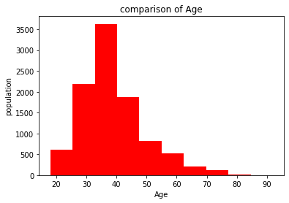

df['HasCrCard'].value_counts()

1 7055

0 2945

Name: HasCrCard, dtype: int64

*# comparison of how many customers hold the credit card*

plt.hist(x = df.HasCrCard, bins = 5, color = 'blue') plt.title('how many people have or not have the credit card') plt.xlabel('customers holding credit card') plt.ylabel('population')

plt.show()

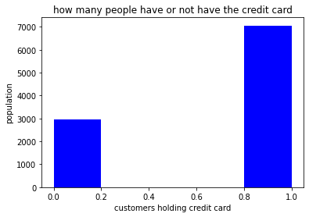

# Bi - Variate Analysis

*# comparing ages in different geographies*

Age = pd.crosstab(df['Age'], df['Geography']) Age.div(Age.sum(1).astype(float), axis = 0).plot(kind = 'bar', stacked = True, figsize = (15,15))

<matplotlib.axes._subplots.AxesSubplot at 0x7fa1a78a13d0>

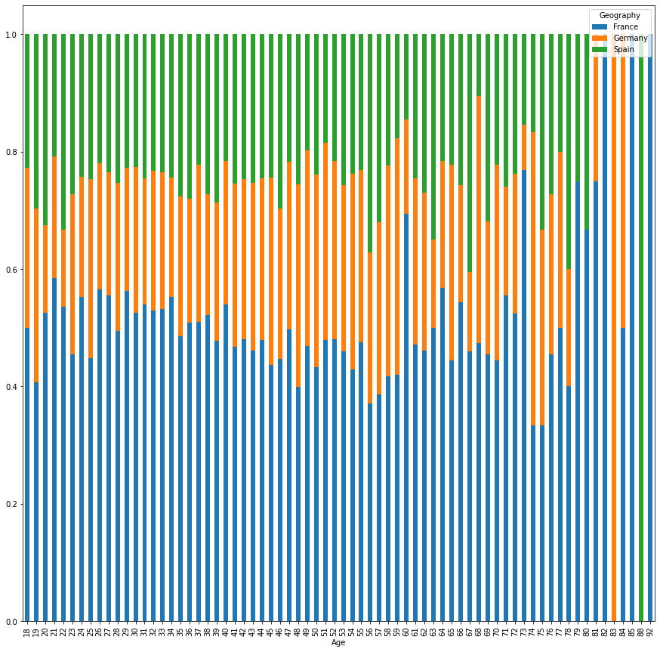

*# comparison between Geography and Gender*

Gender = pd.crosstab(df['Gender'],df['Geography']) Gender.div(Gender.sum(1).astype(float), axis=0).plot(kind="bar", stacked=True, figsize=(6, 6))

<matplotlib.axes._subplots.AxesSubplot at 0x7fa1a6c48bd0>

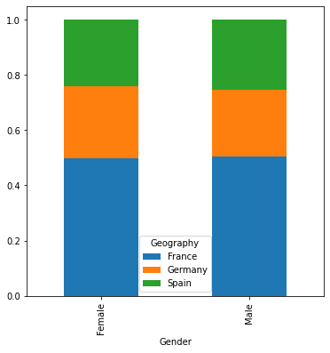

*# comparison of active member in differnt geographies*

IsActiveMember = pd.crosstab(df['IsActiveMember'], df['Geography']) IsActiveMember.div(IsActiveMember.sum(1).astype(float), axis = 0).plot(kind = 'bar',stacked = True, figsize= (6, 6))

<matplotlib.axes._subplots.AxesSubplot at 0x7fa1a6c36810>

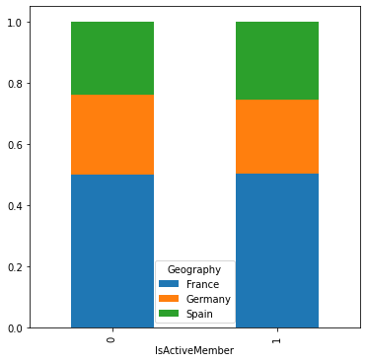

*# calculating total balance in france, germany and spain*

total_france = df.Balance[df.Geography == 'France'].sum() total_germany = df.Balance[df.Geography == 'Germany'].sum() total_spain = df.Balance[df.Geography == 'Spain'].sum()

print("Total Balance in France :",total_france) print("Total Balance in Germany :",total_germany) print("Total Balance in Spain :",total_spain)

Total Balance in France : 311332479.49 Total Balance in Germany : 300402861.38 Total Balance in Spain : 153123552.01

*# plotting a pie chart*

labels = 'France', 'Germany', 'Spain' colors = ['green', 'yellow', 'orange'] sizes = [311, 300, 153]

explode = [ 0.01, 0.01, 0.01]

plt.pie(sizes, colors = colors, labels = labels, explode = explode, shadow

= True)

plt.axis('equal') plt.show()

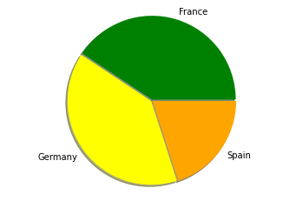

*# comparison between geography and card holders*

HasCrCard = pd.crosstab(df['HasCrCard'], df['Geography']) HasCrCard.div(HasCrCard.sum(1).astype(float), axis = 0).plot(kind = 'bar',stacked = True,figsize = (6, 6))

<matplotlib.axes._subplots.AxesSubplot at 0x7fa1a6b0c0d0>

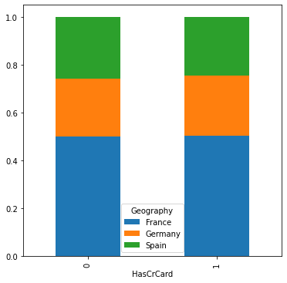

# Multi - Variate Analysis

sns.pairplot(data=df, hue='Exited')

<seaborn.axisgrid.PairGrid at 0x7fa1a1860550>

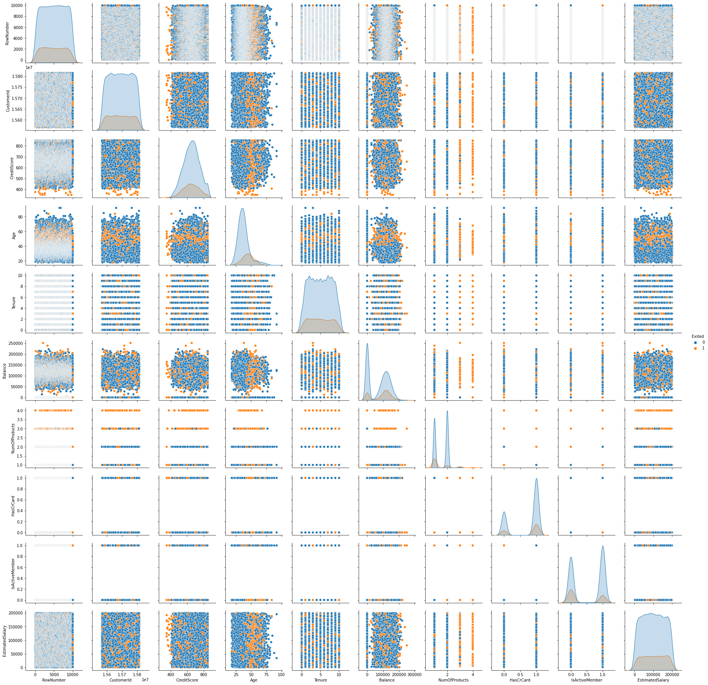

# Perform descriptive statistics on the dataset

df.describe()

|  |  |  |  |  |  |  |  |
| --- | --- | --- | --- | --- | --- | --- | --- |
| \ | RowNumber | CustomerId | CreditScore | | Age | Tenure | |
| count | 10000.00000 | 1.000000e+04 | 10000.000000 | | 10000.000000 | 10000.000000 | |
| mean | 5000.50000 | 1.569094e+07 | 650.528800 | | 38.921800 | 5.012800 | |
| std | 2886.89568 | 7.193619e+04 | 96.653299 | | 10.487806 | 2.892174 | |
| min | 1.00000 | 1.556570e+07 | 350.000000 | | 18.000000 | 0.000000 | |
| 25% | 2500.75000 | 1.562853e+07 | 584.000000 | | 32.000000 | 3.000000 | |
| 50% | 5000.50000 | 1.569074e+07 | 652.000000 | | 37.000000 | 5.000000 | |
| 75% | 7500.25000 | 1.575323e+07 | 718.000000 | | 44.000000 | 7.000000 | |
| max | 10000.00000 | 1.581569e+07 | 850.000000 | | 92.000000 | 10.000000 | |
|  | Balance | NumOfProducts | | HasCrCard | IsActiveMember | | \ |
| count | 10000.000000 | 10000.000000 | | 10000.00000 | 10000.000000 | |  |
| mean | 76485.889288 | 1.530200 | | 0.70550 | 0.515100 | |  |
| std | 62397.405202 | 0.581654 | | 0.45584 | 0.499797 | |  |
| min | 0.000000 | 1.000000 | | 0.00000 | 0.000000 | |  |
| 25% | 0.000000 | 1.000000 | | 0.00000 | 0.000000 | |  |

|  |  |  |  |  |
| --- | --- | --- | --- | --- |
| 50% | 97198.540000 | 1.000000 | 1.00000 | 1.000000 |
| 75% | 127644.240000 | 2.000000 | 1.00000 | 1.000000 |
| max | 250898.090000 | 4.000000 | 1.00000 | 1.000000 |
|  | EstimatedSalary | Exited | | |
| count | 10000.000000 | 10000.000000 | | |
| mean | 100090.239881 | 0.203700 | | |
| std | 57510.492818 | 0.402769 | | |
| min | 11.580000 | 0.000000 | | |
| 25% | 51002.110000 | 0.000000 | | |
| 50% | 100193.915000 | 0.000000 | | |
| 75% | 149388.247500 | 0.000000 | | |
| max | 199992.480000 | 1.000000 | | |

# Handle the Missing values

df.isnull().sum() RowNumber 0

CustomerId 0

Surname 0

CreditScore 0

Geography 0

Gender 0

Age 0

Tenure 0

Balance 0

NumOfProducts 0

HasCrCard 0

IsActiveMember 0

EstimatedSalary 0

Exited 0

dtype: int64

# Find the outliers and replace the outliers

sns.boxplot(data = df, x = 'EstimatedSalary')

<matplotlib.axes._subplots.AxesSubplot at 0x7fa19f13e510>

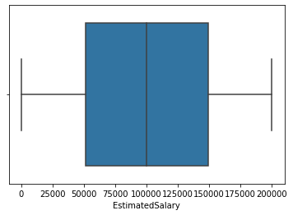

sns.boxplot(data = df, x = 'CreditScore')

<matplotlib.axes._subplots.AxesSubplot at 0x7fa19f0c2410>

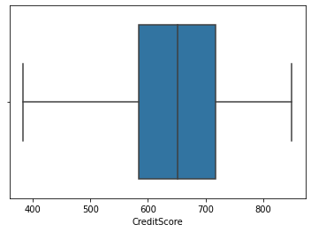

sns.boxplot(data = df, x = 'Balance')

<matplotlib.axes._subplots.AxesSubplot at 0x7fa19f03d1d0>

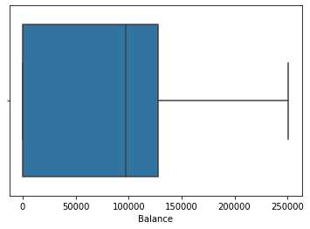

sns.boxplot(data = df, x = 'Age')

<matplotlib.axes._subplots.AxesSubplot at 0x7fa19d74fb10>

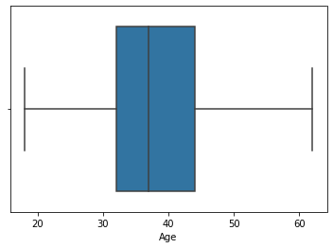

sns.boxplot(data = df, x = 'RowNumber')

<matplotlib.axes._subplots.AxesSubplot at 0x7fa19d7c2b90>

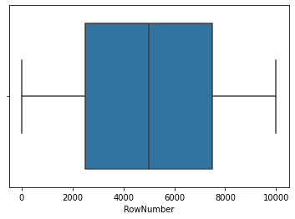

sns.boxplot(data = df, x = 'Tenure')

<matplotlib.axes._subplots.AxesSubplot at 0x7fa19be57c90>

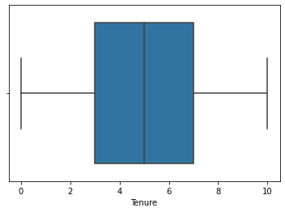

# Check for Categorical columns and perform encoding

x = pd.get_dummies(x) x.head()

|  |  |  |  |  |  |  |  |  |  |  |  |
| --- | --- | --- | --- | --- | --- | --- | --- | --- | --- | --- | --- |
|  | RowNumber | CustomerId | | CreditScore | | Age | Tenure | Surname_Abazu | | \ | |
| 0 | 1.0 | 15634602.0 | | 619.0 | | 42.0 | 2.0 | 0 | |  | |
| 1 | 2.0 | 15647311.0 | | 608.0 | | 41.0 | 1.0 | 0 | |  | |
| 2 | 3.0 | 15619304.0 | | 502.0 | | 42.0 | 8.0 | 0 | |  | |
| 3 | 4.0 | 15701354.0 | | 699.0 | | 39.0 | 1.0 | 0 | |  | |
| 4 | 5.0 | 15737888.0 | | 850.0 | | 43.0 | 2.0 | 0 | |  | |
| \ | Surname_Abbie | | Surname_Abbott | | Surname_Abdullah | | | Surname_Abdulov | | ... | |
| 0 | 0 | | 0 | | 0 | | | 0 | | ... | |
| 1 | 0 | | 0 | | 0 | | | 0 | | ... | |
| 2 | 0 | | 0 | | 0 | | | 0 | | ... | |
| 3 | 0 | | 0 | | 0 | | | 0 | | ... | |
| 4 | 0 | | 0 | | 0 | | | 0 | | ... | |
|  | Surname_Zubarev | | Surname_Zubareva | | | Surname_Zuev | | Surname_Zuyev | | \ | |
| 0 | 0 | | 0 | | | 0 | | 0 | |  | |
| 1 | 0 | | 0 | | | 0 | | 0 | |  | |
| 2 | 0 | | 0 | | | 0 | | 0 | |  | |
| 3 | 0 | | 0 | | | 0 | | 0 | |  | |
| 4 | 0 | | 0 | | | 0 | | 0 | |  | |
|  | Surname_Zuyeva | | Geography_France | | | Geography_Germany | | | Geography_Spain | | \ |
| 0 | 0 | | 1 | | | 0 | | | 0 | |  |
| 1 | 0 | | 0 | | | 0 | | | 1 | |  |
| 2 | 0 | | 1 | | | 0 | | | 0 | |  |
| 3 | 0 | | 1 | | | 0 | | | 0 | |  |
| 4 | 0 | | 0 | | | 0 | | | 1 | |  |
|  | Gender_Female | | Gender_Male | | |  | | |  | |  |
| 0 | 1 | | 0 | | |  | | |  | |  |
| 1 | 1 | | 0 | | |  | | |  | |  |
| 2 | 1 | | 0 | | |  | | |  | |  |
| 3 | 1 | | 0 | | |  | | |  | |  |
| 4 | 1 | | 0 | | |  | | |  | |  |

[5 rows x 2942 columns]

# Split the data into dependent and independent variables

*# splitting the dataset into x(independent variables) and y(dependent variables)*

x = df.iloc[:,0:8]

y = df.iloc[:,8]

print(x.shape) print(y.shape)

print(x.columns)

(10000, 8)

(10000,)

Index(['RowNumber', 'CustomerId', 'Surname', 'CreditScore', 'Geography', 'Gender', 'Age', 'Tenure'],

dtype='object')

# Scale the independent variables

from sklearn.preprocessing import StandardScaler

sc = StandardScaler()

x_train = sc.fit_transform(x_train) x_test = sc.fit_transform(x_test)

x_train = pd.DataFrame(x_train) x_train.head()

|  |  |  |  |  |  |  |  |  |  |  |  |  |  |  |  |  |
| --- | --- | --- | --- | --- | --- | --- | --- | --- | --- | --- | --- | --- | --- | --- | --- | --- |
| 0  \  0 -0.702176 | | | 1  -1.343330 | | | 2  -0.736828 | | 3  0.042283 | | 4  0.008860 | | 5  -0.016332 | | 6  0.0 | | 7 |
| -0.0231 | | |  | | |  | |  | |  | |  | |  | |  |
| 1 -1.485722 | | | 1.558330 | | | 1.025257 | | -0.674496 | | 0.008860 | | -0.016332 | | 0.0 | |  |
| -0.0231 | | |  | | |  | |  | |  | |  | |  | |  |
| 2 -0.524522 | | | -0.655156 | | | 0.808861 | | -0.469702 | | 1.393293 | | -0.016332 | | 0.0 | |  |
| -0.0231 | | |  | | |  | |  | |  | |  | |  | |  |
| 3 -1.167396 | | | 1.200594 | | | 0.396677 | | -0.060114 | | 0.008860 | | -0.016332 | | 0.0 | |  |
| -0.0231 | | |  | | |  | |  | |  | |  | |  | |  |
| 4 -1.451159 | | | 0.778798 | | | -0.468908 | | 1.373444 | | 0.701077 | | -0.016332 | | 0.0 | |  |
| -0.0231 | | |  | | |  | |  | |  | |  | |  | |  |
| 8 | 9 | | ... | | | 2932 | 2933 | | 2934 | | 2935 | | 2936 | | | 2937 |
| \ 0 | 0.0 | 0.0 | | ... | -0.011548 | | 0.0 | | -0.011548 | | -0.011548 | | -0.016332 | | -1.015588 | |
| 1 | 0.0 | 0.0 | | ... | -0.011548 | | 0.0 | | -0.011548 | | -0.011548 | | -0.016332 | | 0.984651 | |
| 2 | 0.0 | 0.0 | | ... | -0.011548 | | 0.0 | | -0.011548 | | -0.011548 | | -0.016332 | | -1.015588 | |
| 3 | 0.0 | 0.0 | | ... | -0.011548 | | 0.0 | | -0.011548 | | -0.011548 | | -0.016332 | | -1.015588 | |
| 4 | 0.0 | 0.0 | | ... | -0.011548 | | 0.0 | | -0.011548 | | -0.011548 | | -0.016332 | | 0.984651 | |

|  |  |  |  |
| --- | --- | --- | --- |
| 2938 | 2939 | 2940 | 2941 |
| 0 1.760216 | -0.574682 | 1.087261 | -1.087261 |
| 1 -0.568112 | -0.574682 | 1.087261 | -1.087261 |
| 2 -0.568112 | 1.740094 | 1.087261 | -1.087261 |
| 3 -0.568112 | 1.740094 | -0.919743 | 0.919743 |
| 4 -0.568112 | -0.574682 | -0.919743 | 0.919743 |

[5 rows x 2942 columns]

# Split the data into training and testing

from sklearn.model_selection import train_test_split

x_train, x_test, y_train, y_test = train_test_split(x, y, test_size = 0.25, random_state = 0)

print(x_train.shape)

print(y_train.shape) print(x_test.shape) print(y_test.shape)

(7500, 2942)

(7500,)

(2500, 2942)

(2500,)